Program Code

import java.util.*;

/**

A program to Display the categories and select items then

getting bill.

*/

public class Paints1

{

int choice, ch, nextcus, t=0, billno=1,contine;

double price, cost=0.0, tax, tamt, amt=0.0, tot=0.0, dis,quantity,tdamt;

String title, cname, cph, add;

Scanner in = new Scanner(System.in);

public void Welcome_Purchace()

{

System.out.println("\t\t\t\t\t VENKATESHWARA PAINTS AND HARDWARE");

System.out.println("************************************************************************************************");

System.out.println("\t\tWELCOME TO VENKATESHWARA PAINTS AND HARDWARE");

System.out.println("****************************************************************************************");

System.out.println();

System.out.println("Enter your Name");

cname=in.nextLine();

cname=in.nextLine();

System.out.println("Enter your Phone Number");

cph=in.nextLine();

System.out.println("Enter your Address");

add=in.nextLine();

tot=0.0;

Main_Menu();

}//end of welcome_purchase()

public void Main_Menu()

{

System.out.println();

System.out.println();

System.out.println("\t\t\t\t MENU");

System.out.println("\t\t\t 1.Paints");

System.out.println("\t\t\t 2.Nails");

System.out.println("\t\t\t 3.Cement");

System.out.println("\t\t\t 4.Brushes");

System.out.println("\t\t\t 5.Oil paints");

System.out.println("\t\t\t 6.Bill");

System.out.println();

System.out.println("Enter Your Choice");

choice = in.nextInt();

switch (choice)

{

case 1:paints();

break;

case 2:nails();

break;

case 3:cement();

break;

case 4:brushes();

break;

case 5:oil_paints();

break;

case 6:bill();

break;

default:System.out.println("You have entered a wrong choice");

break;

}//end of switch

if (choice!=9)

{

System.out.println();

System.out.println();

System.out.println("============================================================================");

System.out.println();

System.out.println("Purchased Item Is "+title);

System.out.println("Purchased Item price"+price*quantity);

System.out.println();

System.out.println("=================================================================================");

System.out.println();

System.out.println();

amt=price*quantity;

tot=tot+amt;

}

System.out.println();

System.out.println("Do you want to continue with your purchase?\n 1 for MAIN MENU /n 2for Exit");

contine=in.nextInt();

if(contine==1)

Main_Menu();

else

bill();

System.out.println();

System.out.println();

System.out.println();

System.out.println("Do you want to continue with the next customer? \n 1 for YES & 2 for no");

nextcus=in.nextInt();

if(nextcus==1)

{

Welcome_Purchace();

billno++;

}

else

System.exit(0);

}//end of main menu

public void paints()

{

Scanner in=new Scanner(System.in);

System.out.println();

System.out.println("Select the required category");

System.out.println();

System.out.println("1.Wall primer");

System.out.println("2.Metal primer");

System.out.println("3.Exterior emulsion");

System.out.println("4.Interior emulsion");

System.out.println("5.Stainers");

System.out.println("6.Return to main_menu");

System.out.println("Enter your choice");

ch=in.nextInt();

switch(ch)

{

case 1:wall_primer();

break;

case 2:metal_primer();

break;

case 3:exterior_emulsion();

break;

case 4:interior_emulsion();

break;

case 5:stainers();

break;

case 6:Main_Menu();

default:System.out.println("You have entered a wrong choice");

System.out.println("please enter a nymber between 1-6");

break;

}

}

public void wall_primer()

{

Scanner in=new Scanner(System.in);

System.out.println("1.Intreior wall primer");

System.out.println("2.exterior wall primer");

System.out.println("3.Return to main_menu");

System.out.println("Enter your choice");

choice=in.nextInt();

System.out.println("Enter number of liters");

quantity=in.nextDouble();

switch(ch)

{

case 1:title="Interior wall primer";

price=140;

break;

case 2:title="Exterior wall primer";

price=150;

break;

case 3:Main_Menu();

break;

default:System.out.println("You have enetred a wrong choice");

System.out.println("please enter a nymber between 1-3");

break;

}

}

public void metal_primer()

{

Scanner in=new Scanner(System.in);

System.out.println("Enter number of liters reqired");

quantity=in.nextInt();

price=250;

}

public void exterior_emulsion()

{

Scanner in=new Scanner(System.in);

System.out.println("1.Ivary");

System.out.println("2.Blue");

System.out.println("3.gray");

System.out.println("4.Return to main menu");

System.out.println("Enter your choice");

choice=in.nextInt();

switch(choice)

{

case 1:title="Ivary";

System.out.println("Enter number of liters required");

quantity=in.nextDouble();

price=200;

break;

case 2:title="Blue";

System.out.println("Enter number of liters required");

quantity=in.nextDouble();

price=210;

break;

case 3:title="Gray";

System.out.println("Enter number of liters required");

quantity=in.nextDouble();

price=230;

break;

case 4:Main_Menu();

break;

default:System.out.println("You have entered a wrong choice");

System.out.println("please enter a nymber between 1-4");

break;

}

public void interior_emulsion()

{

Scanner in=new Scanner(System.in);

System.out.println("1.Candy");

System.out.println("2.Aquamarine");

System.out.println("3.Light green");

System.out.println("4.Light brown");

System.out.println("5.Light red");

System.out.println("6.Light orange");

System.out.println("7.Return to main menu");

System.out.println("Entre your choice");

choice=in.nextInt();

switch(choice)

{

case 1:title="Candy";

System.out.println("Enter number of liters required");

quantity=in.nextDouble();

price=180;

break;

case 2:title="Aquamarine";

System.out.println("Enter number of liters required");

quantity=in.nextDouble();

price=180;

break;

case 3:title="Light green";

System.out.println("Enter number of liters required");

quantity=in.nextDouble();

price=180;

break;

case 4:title="light brown";

System.out.println("Enter number of liters require");

quantity=in.nextDouble();

price=190;

break;

case 5:title="light red";

System.out.println("Enter number of liters required");

quantity=in.nextDouble();

price=200;

break;

case 6:title="Light orange";

System.out.println("Enter number of liters required");

quantity=in.nextDouble();

price=190;

break;

case 7:Main_Menu();

break;

default:System.out.println("You have entered a wrong choice");

System.out.println("please enter a nymber between 1 - 7");

break;

}

}

public void stainers()

{

System.out.println("1.Fast red");

System.out.println("2.Violet");

System.out.println("3.Yellow");

System.out.println("4.Fy green");

System.out.println("5.Fast blue");

System.out.println("6.Fast brown");

System.out.println("Enetr your choice");

choice=in.nextInt();

switch(choice)

{

case 1:title="Fast red";

System.out.println("Enter number of liters required");

quantity=in.nextDouble();

price=45;

break;

case 2:title="Violet";

System.out.println("Enter number of liters required");

quantity=in.nextDouble();

price=30;

break;

case 3:title="Yellow";

System.out.println("Enter number of liters required");

quantity=in.nextDouble();

price=35;

break;

case 4:title="Fy green";

System.out.println("Enter number of liters required");

quantity=in.nextDouble();

price=40;

break;

case 5:title="fast blue";

System.out.println("Enter number of liters required");

quantity=in.nextDouble();

price=35;

break;

case 6:title="fast brown";

System.out.println("Enter number of liters required");

quantity=in.nextDouble();

price=40;

break;

case 7:Main_Menu();

break;

default:System.out.println("You have entered a wrong choice");

System.out.println("please enter a nymber between 1 - 7");

break;

}

}

public void nails()

{

Scanner in=new Scanner(System.in);

System.out.println("1. 2inch");

System.out.println("2. 2.5inch");

System.out.println("3. 3inch");

System.out.println("4. 4inch");

System.out.println(" Enter your choice");

choice=in.nextInt();

switch(choice)

{

case 1:title="2 Inch nail";

System.out.println("Enter number of kilograms you wish to buy");

quantity=in.nextDouble();

price=60;

break;

case 2:title="2.5 Inch nail";

System.out.println("Enter number of kilograms you wish to buy");

quantity=in.nextDouble();

price=65;

break;

case 3:title="3 Inch nail";

System.out.println("Enter number of kilograms you wish to buy");

quantity=in.nextDouble();

price=70;

break;

case 4:title="4 Inch nail";

System.out.println("Enter number of kilograms you wish to buy");

quantity=in.nextDouble();

price=75;

break;

case 5:Main_Menu();

break;

default:System.out.println("You have entered a wrong choice");

System.out.println("please enter a nymber between 1-5");

break;

}

}

public void cement()

{

Scanner in=new Scanner(System.in);

System.out.println("1.Ultratech cement");

System.out.println("2.ACC cement");

System.out.println("3.Priya cement");

System.out.println("4.Ambuja cement");

System.out.println("5.Return to main_menu");

System.out.println("Enter your choice");

switch(choice)

{

case 1:title="Ultratech";

System.out.println("Enter number of kilograms you wish to buy");

quantity=in.nextDouble();

price=170;

break;

case 2:title="ACC cement";

System.out.println("Enter number of kilograms you wish to buy");

quantity=in.nextDouble();

price=175;

break;

case 3:title="Priya";

System.out.println("Enter number of kilograms you wish to buy");

quantity=in.nextDouble();

price=180;

break;

case 4:title="Ambuja";

System.out.println("Enter number of kilograms you wish to buy");

quantity=in.nextDouble();

price=150;

break;

case 5:Main_Menu();

break;

default:System.out.println("You have entered a wrong choice");

System.out.println("please enter a nymber between 1-5");

break;

}

}

public void brushes()

{

Scanner in=new Scanner(System.in);

System.out.println("1. 1inch");

System.out.println("2. 2inch");

System.out.println("3. 3inch");

System.out.println("Enetr your choice");

choice=in.nextInt();

switch(choice)

{

case 1:title="1 inch";

System.out.println("Enter number of brushes reqired");

quantity=in.nextDouble();

price=60;

break;

case 2:title="2 inch";

System.out.println("Enter number of brushes reqired");

quantity=in.nextDouble();

price=70;

break;

case 3:title="3 inch";

System.out.println("Enter number of brushes reqired");

quantity=in.nextDouble();

price=80;

break;

case 4:Main_Menu();

break;

default:System.out.println("You have entered a wrong choice");

System.out.println("please enter a nymber between 1-4");

break;

}

}

public void oil_paints()

{

Scanner in=new Scanner(System.in);

System.out.println("1.Golden brown");

System.out.println("2.Dawn");

System.out.println("3.Brown");

System.out.println("4.Feroza");

System.out.println("5.Sky blue");

System.out.println("6.White");

System.out.println("7.Green");

System.out.println("8.Return to main_menu");

System.out.println("Enter your choice");

choice=in.nextInt();

switch(choice)

{

case 1:title="Golden brown";

System.out.println("Enter number of liters reqiured");

quantity=in.nextInt();

price=250;

break;

case 2:title="Dawn";

System.out.println("Enter number of liters reqiured");

quantity=in.nextInt();

price=280;

break;

case 3:title=" brown";

System.out.println("Enter number of liters reqiured");

quantity=in.nextInt();

price=250;

break;

case 4:title="Feroza";

System.out.println("Enter number of liters reqiured");

quantity=in.nextInt();

price=260;

break;

case 5:title="Sky blue";

System.out.println("Enter number of liters reqiured");

quantity=in.nextInt();

price=250;

break;

case 6:title="White";

System.out.println("Enter number of liters reqiured");

quantity=in.nextInt();

price=230;

break;

case 7:title="Green";

System.out.println("Enter number of liters reqiured");

quantity=in.nextInt();

price=280;

break;

case 8:Main_Menu();

break;

default:System.out.println("You have entered a wrong choice");

System.out.println("please enter a nymber between 1-8");

break;

}

}

public void bill()

{

Scanner in=new Scanner(System.in);

{

System.out.println();

System.out.println();

System.out.println();

System.out.println();

System.out.println("\t\t\t VENKATESHWARA PAINTS AND HARDWARE");

System.out.println();

System.out.println("$$$$$$$$$$$$$$$$$$$$$$$$$$$$$$$$$$$$$$$$$$$$$$$$$$$$$$$$$$$$$$$$$$$$$$$$$$$$$$");

System.out.println("Address:Opp to santhe gate");

System.out.println("MB Road, Kolar-563101");

System.out.println("Conatct Number: 9241102233");

System.out.println();

System.out.println();

tax=tot*(18/100.0);

tamt=tot+tax;

if (tamt<2500)

dis=3.0;

else if(tamt<5000)

dis=4.0;

else

dis=5.0;

dis=tamt*(dis/100.0);

tdamt=tamt-dis;

System.out.println("$$$$$$$$$$$$$$$$$$$$$$$$$$$$$$$$$$$$$$$$$$$$$$$$$$$$$$$$$$$$$$$$$$$$$$$$$$$");

System.out.println("Customer details");

System.out.println("Name="+cname);

System.out.println("Conatct number"+cph);

System.out.println("Address="+add);

System.out.println("Bill number="+billno);

System.out.println("$$$$$$$$$$$$$$$$$$$$$$$$$$$$$$$$$$$$$$$$$$$$$$$$$$$$$$$$$$$$$$$$$$$$$$$$$$$$$$$$$$$");

System.out.println("\t Price of all the purcg=hased item in Rs="+tot);

System.out.println("\t Tax on ur purchase ="+tax);

System.out.println("\t Discount on your purchase="+dis);

System.out.println("$$$$$$$$$$$$$$$$$$$$$$$$$$$$$$$$$$$$$$$$$$$$$$$$$$$$$$$$$$$$$$$$$$$$$$$$$$$$$$$$$$$$$$$$$$$");

System.out.println("Final Amount to be paid on your purchase"+tdamt);

}

}

}

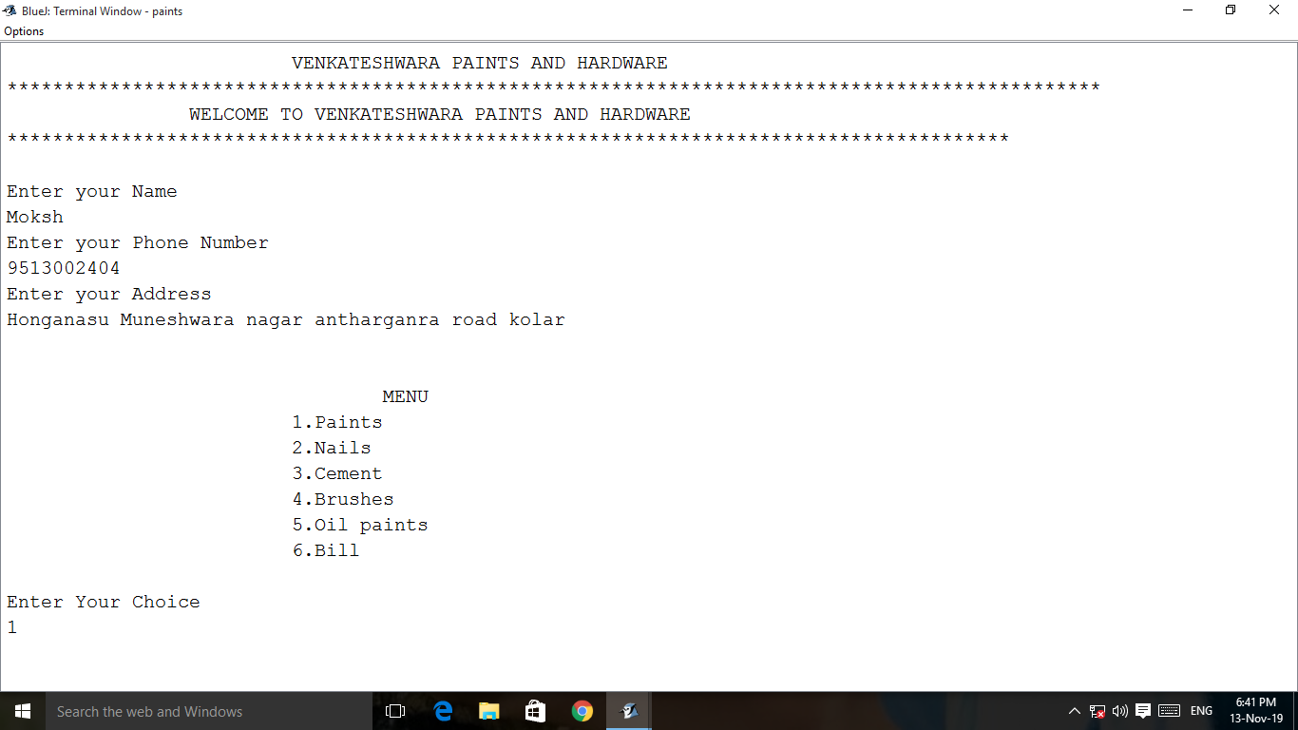

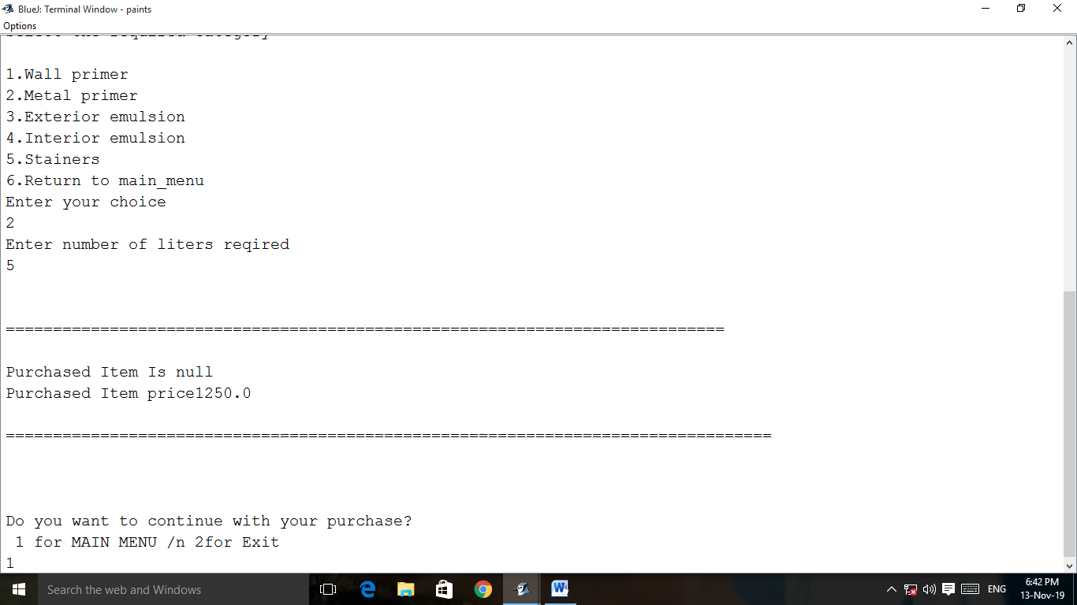

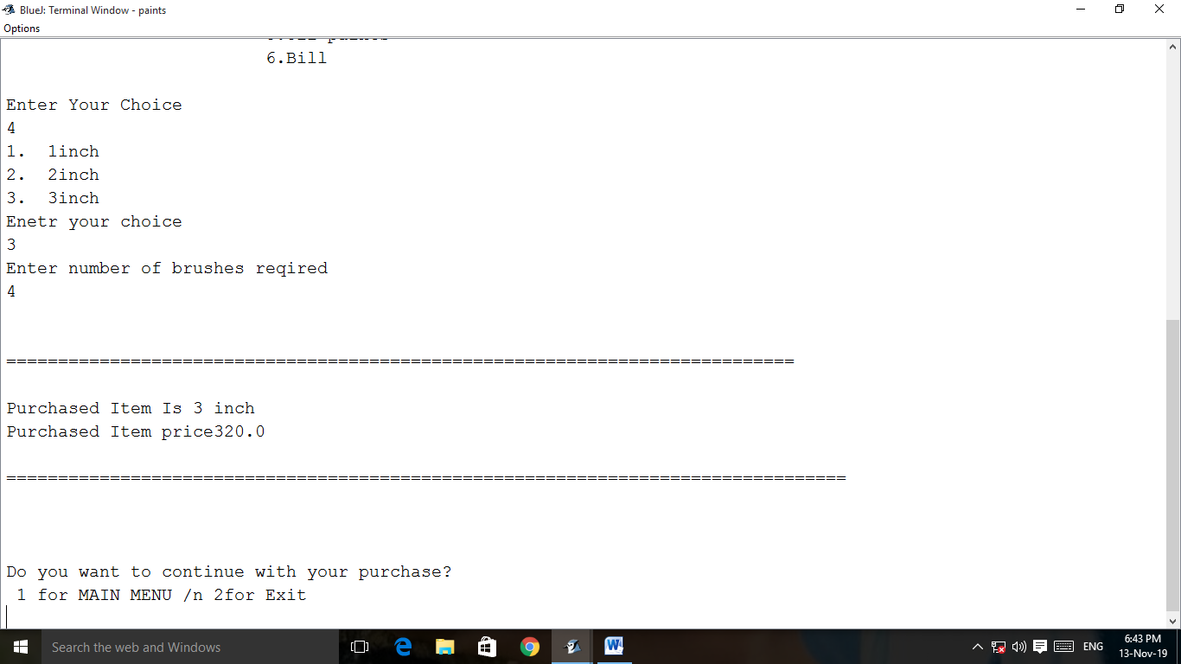

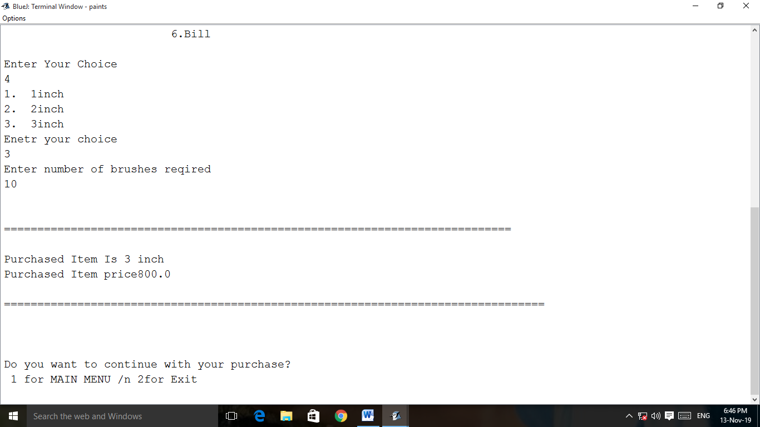

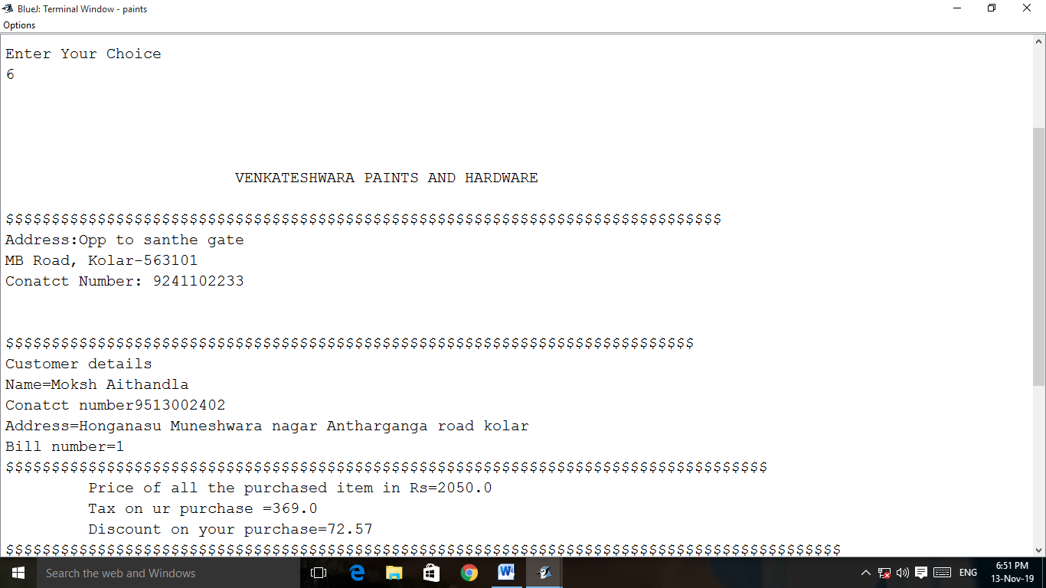

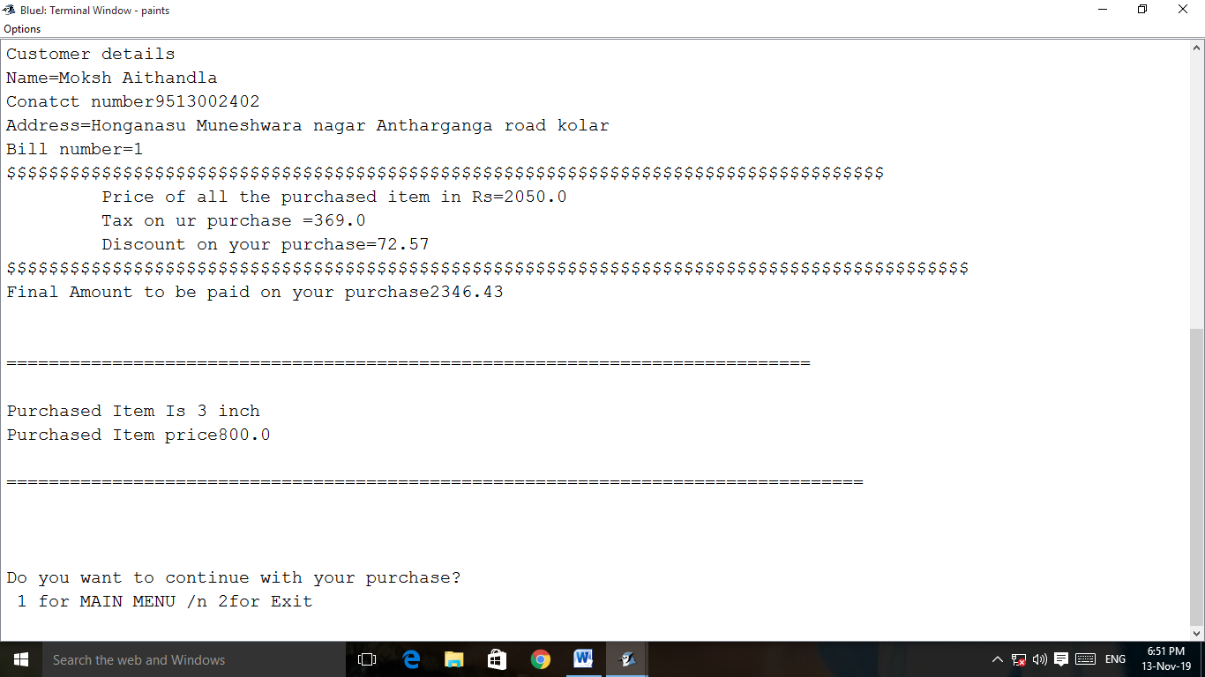

VARIABLE DESCRIPTION